A Project on

Online Job Portal
(firstjob.com)

Submitted To :
Hestabit Technology

Submitted By :-

Apurva

Aanchal Agarwal

Abhishek tyagi

Akash Sharma

Mohd Hammad

pushpender

Table of contents

Chapter 1: INTRODUCTION ............................................................................
1. Abstract..........................................................................................
2. Need for System...................................................................................................................
3. Admin Module ..................................................................................................................
4. User Module............................................................................................................
5. Sample Screen shot......................................................................................................................
6. ..............................................................................................................

Abstract(Project Profile)
----------------------------------

Project Title --------- firstjob
Objective------------- Our System provide facilities to apply for online job
Platform--------------- Web Based Application
Front End-------------- Html,css
Back End--------------- php
Other Tools------------ jquery, Script
Project Duration ------4Days

NEED FOR SYSTEM
------------------------------
❖ Provide easy and quick apply of job from this application.

❖ This application provide user on criteria that is alone by specifice user account.

ADMIN MODULE
------------------------
Admin can Manage Dashboard

Admin can View Detail of user

Admin can View graph according to weekely user

Admin can add new skills

User MODULE
---------------------
user can Apply for job in our site.

Sample Screenshot
---------------------------

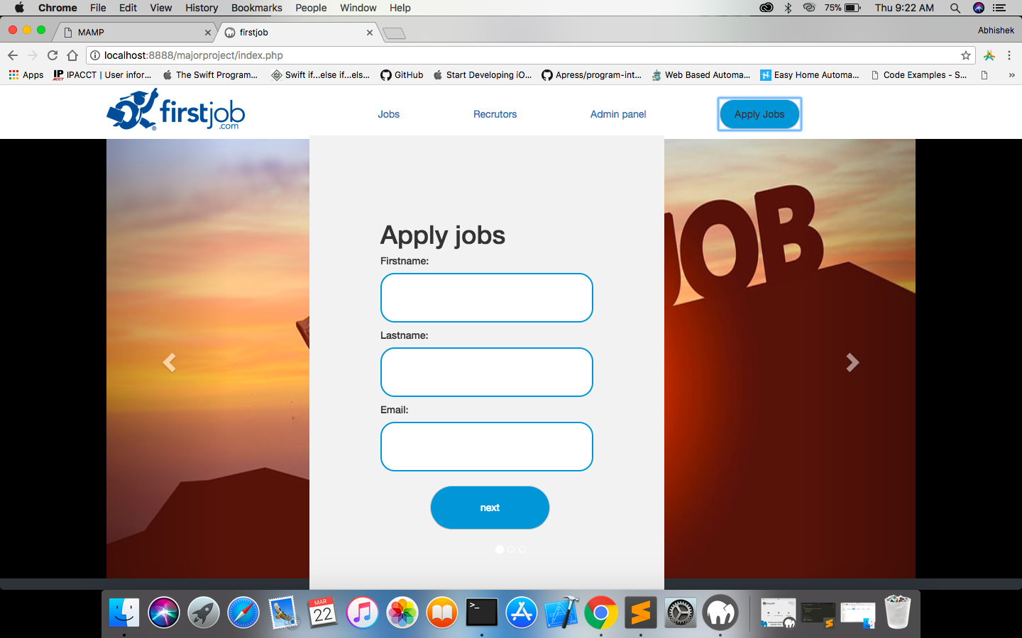

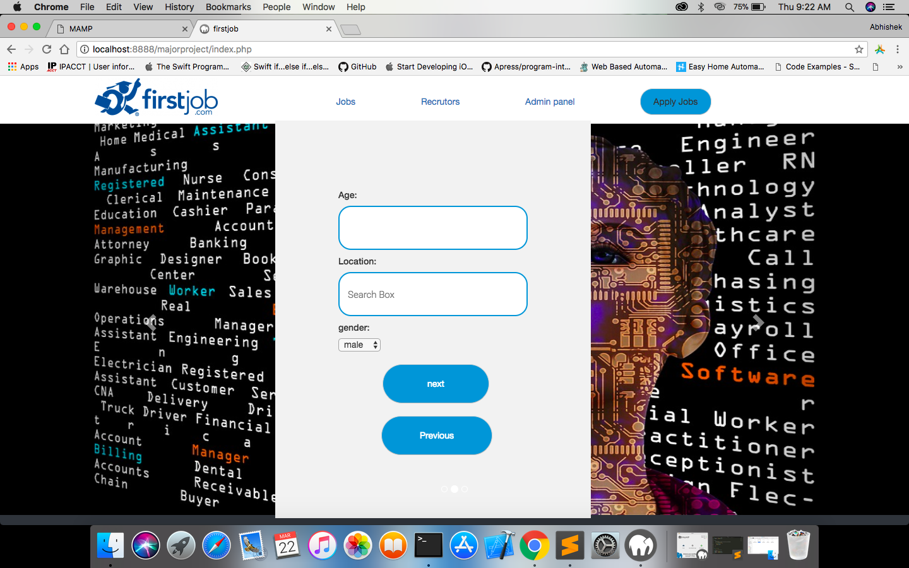

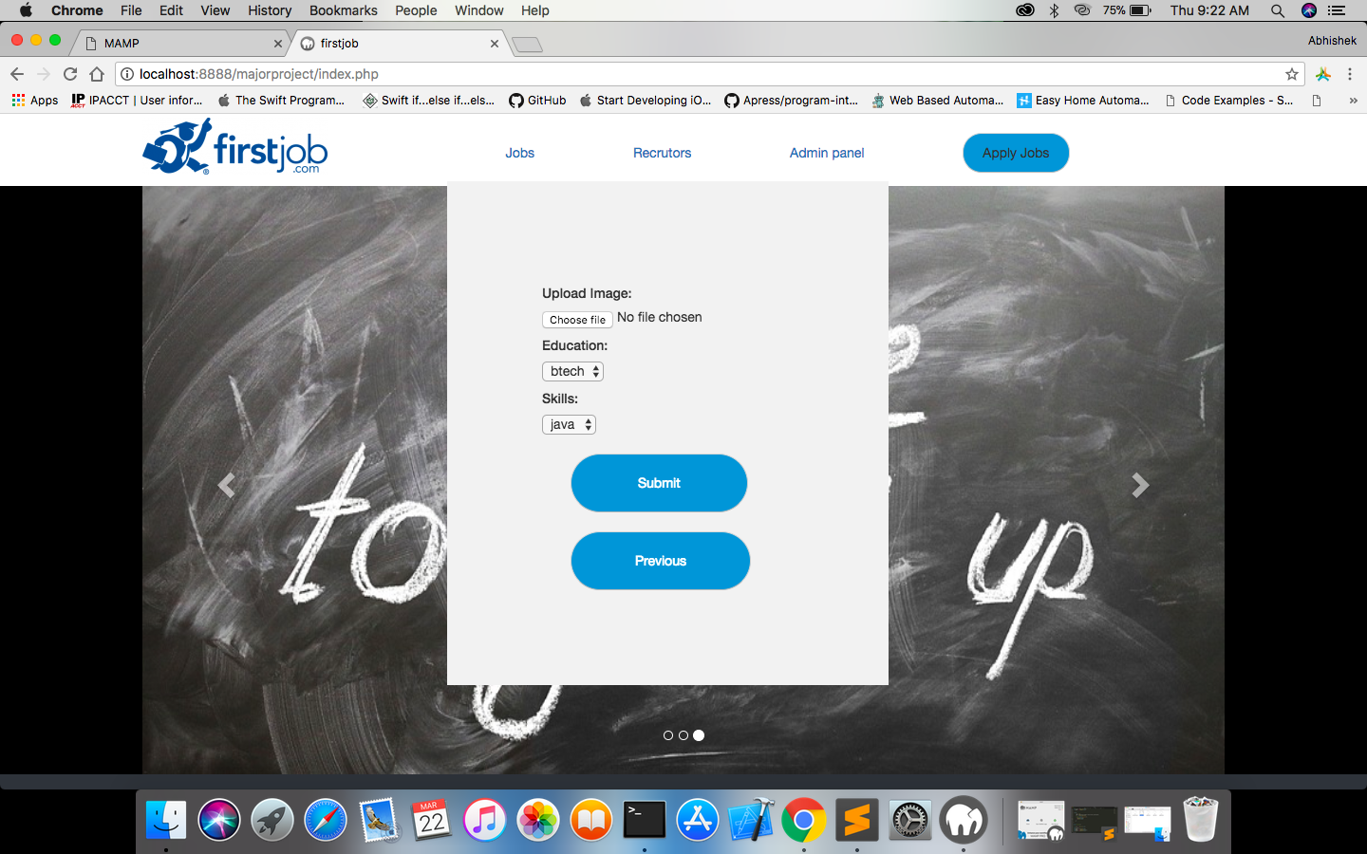
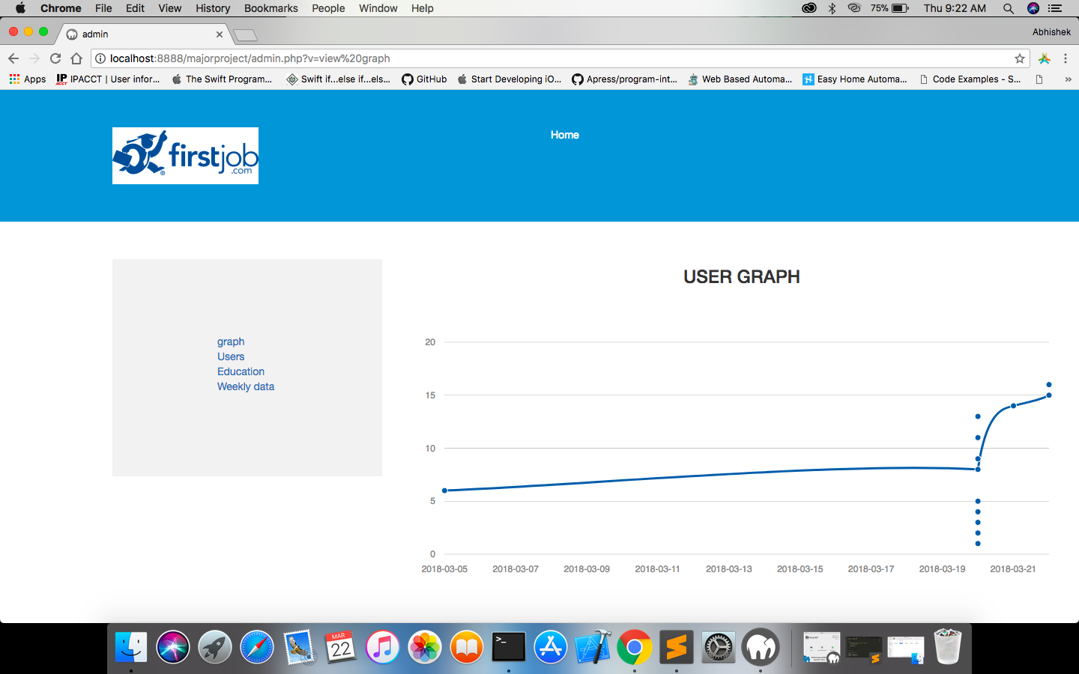
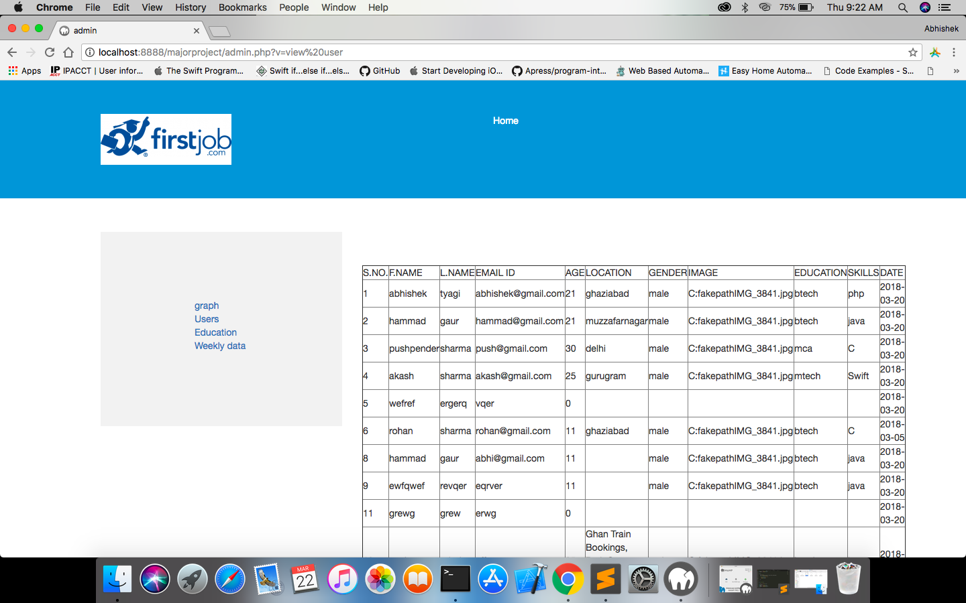
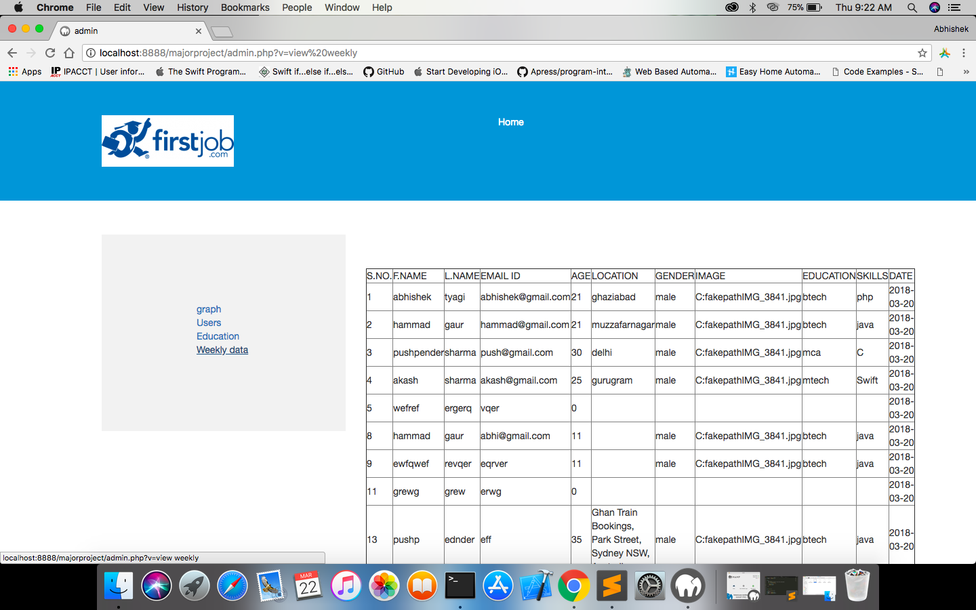
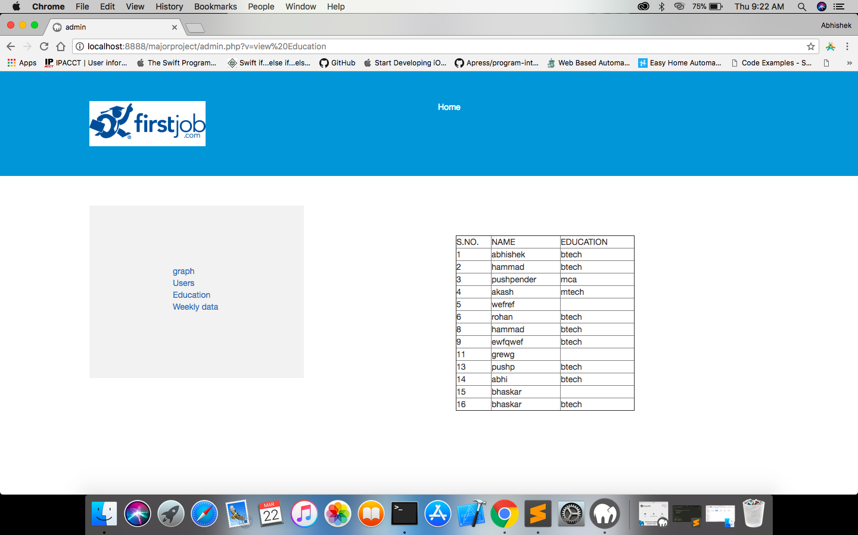

----------------------------Thank you----------------------

